**Week 1: Data Analysis Report**

**(Team 33)**

**Submitted By:**

* Maryam Zaman ([maryam30zaman@gmail.com](mailto:maryam30zaman@gmail.com))
* Syed M Qasim Zaidi (smqzaidi725@gmailcom)
* Noor Ul Ain Zahid ([noorulainzahidofficial@gmail.com](mailto:noorulainzahidofficial@gmail.com))
* Tobi Adegbola ([tobiadegbola98@gmail.com](mailto:tobiadegbola98@gmail.com))
* Husna Abbas ([husnaabbas328@gmail.com](mailto:husnaabbas328@gmail.com))

|  |
| --- |
| Photo displaying partial image of two pie charts on a canvas-textured page |
| "Facebook Ad Campaign Analysis: Identifying Underperforming Campaigns for Discontinuation"  Data Visualizations |
| |  |  |  | | --- | --- | --- | | Team 33 | 7/14/25 | Visualizations | |

Table of Contents

**Introduction** 2

**Analysis Plan table** 2

**Overview of Data Columns** 2

**Key Visualizations & Insights** 4

**i. Total Clicks by Campaign** 4

**ii. Average reach & Impression by Campaign:** 6

**iii. Average Frequency by Campaign** 7

**iv. Average CPR and CPC by Campaign** 8

**v. Amount Spent vs ULC (Scatter Plot)** 9

**vi. CTR vs Frequency (Scatter Plot)** 10

**vii. CTR & Unique CTR by Campaign** 11

**viii. Heatmap (CPR by Age & Geography)** 12

**Suggested Campaigns to Discontinue** 13

**Final Recommendation** 13

**Appendix - Additional Visualizations** 14

**i .Scatter plot** 14

**ii.Bar Chart** 15

**iii. Pie Chart** 16

**iv.Scatter Plot** 17

**Conclusion** 17

# **Introduction**

In the first week of the Data Visualization Virtual Internship with Excelerate and GlobalShala, our team started looking at Facebook ad campaign data. We checked things like how many people saw the ads, how many clicked, and how much money was spent. Our main goal was to find which ads were not doing well and should be stopped, and we used easy-to-understand charts to show our results.

# **Analysis Plan table**

This is the plan table we followed to analyze the ad campaigns:

|  |  |  |
| --- | --- | --- |
| Step | What We Did | Why We Did It |
| 1 | Checked all columns in the dataset | To understand what each column means |
| 2 | Focused on key numbers (clicks, reach, cost, etc.) | To see how well each campaign performed |
| 3 | Made charts (bar charts, scatter plots, heatmaps) | To make the data easier to see and compare |
| 4 | Compared all campaigns | To find out which ones did good or bad |
| 5 | Found weak campaigns with high cost, low results | To know which ads were wasting money |
| 6 | Gave final suggestion | To help the team save money by stopping bad campaigns |

# **Overview of Data Columns**

The dataset contains detailed information about Facebook ad campaigns run by GlobalShala. The columns are grouped into the following categories:

1. **Campaign Info:**

|  |  |
| --- | --- |
| Column Name | Meaning |
| Campaign ID | A unique code for each ad campaign. |
| Campaign Name | The name given to the ad campaign like SHU_6, SHU_3, etc. Helps identify the purpose of the campaign. |
| Audience | The type of people the ad is targeted to e.g. Students, Educators. |
| Age | The age group the ad was shown to like 13-17, 18-24, etc. |
| Geography | The countries where the ad was shown like India, Pakistan, USA, UK. |

1. **Ad Reach and Engagement:**

|  |  |
| --- | --- |
| Column Name | Meaning |
| Reach | Number of unique people who saw your ad at least once.  Example: If 1 person saw the ad 3 times, Reach = 1. |
| Impressions | Total number of times the ad was shown, including repeats. Example: If 1 person sees it 3 times, Impressions = 3. |
| Frequency | How many times on average each person saw the ad. It is calculated like Frequency = Impressions ÷ Reach |

1. **Click Data:**

|  |  |
| --- | --- |
| Column Name | Meaning |
| Clicks | Total number of times people clicked anywhere on the ad. |
| Unique Clicks | Number of different people who clicked no matter how many times each person clicked. |
| Unique Link Clicks (ULC) | Number of different people who clicked the main link in your ad not just likes, comments, or photo views. This is more valuable for driving traffic. |

1. **Performance Metrics:**

|  |  |
| --- | --- |
| Column Name | Meaning |
| Click-Through Rate (CTR) | What percentage of people who saw the ad actually clicked on it. Calculated as: CTR = (Clicks ÷ Impressions) × 100 |
| Unique Click-Through Rate (Unique CTR) | Same as CTR, but based on unique clicks only. Shows how well the ad attracts individual users. |

1. **Cost Metrics:**

|  |  |
| --- | --- |
| Column Name | Meaning |
| Amount Spent in INR | How much money you spent on that ad campaign (in Indian Rupees). |
| Cost Per Click (CPC) | Average cost per click. Calculated as: `CPC = Amount Spent |

# **Key Visualizations & Insights**

Following are the key insights from our visual analysis of the ad campaigns, each helping us identify which ads performed well and which need to be discontinued.

## **i. Total Clicks by Campaign**

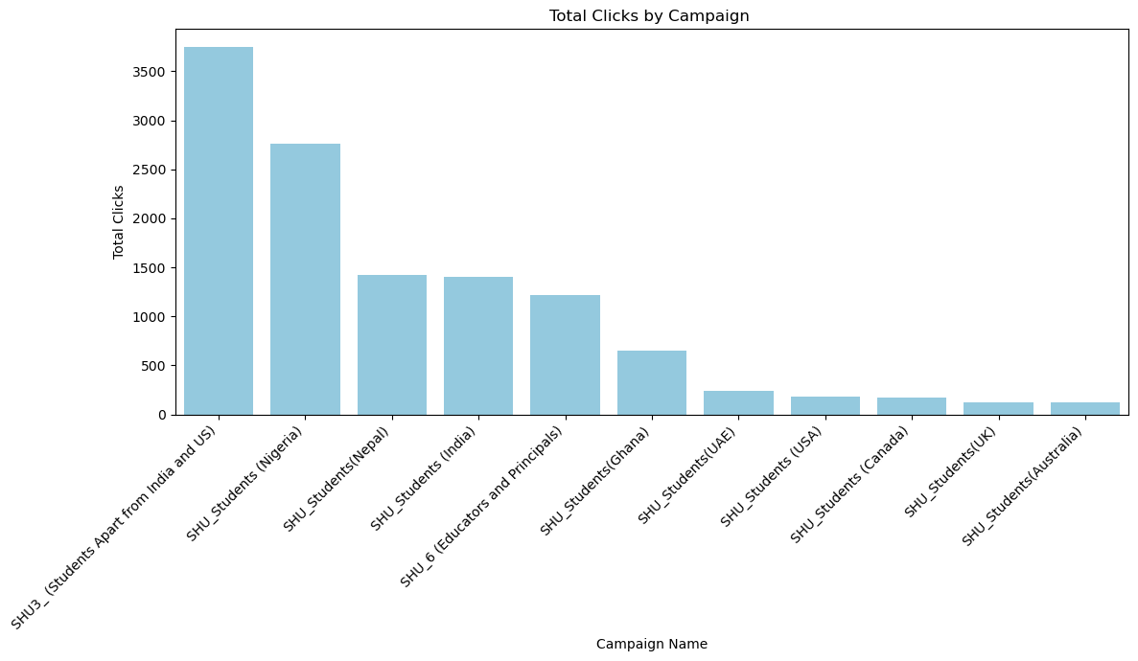

#### **Insight findings:**

|  |  |
| --- | --- |
| Highest Clicks Campaigns | Lowest Clicks Campaigns |
| SHU3_ (Students Apart from India and US) | SHU_Students (Australia) |
| SHU_Students (Nigeria) | SHU_Students (UK) |
| SHU_Students (Nepal) | SHU_Students (Canada) |
| SHU_Students (India) | SHU_Students (USA) |

**Interpretation:**

The bar chart shows that the campaigns with the highest number of clicks were for SHU3 (Students apart from India and US), Nigeria, Nepal, and India. This means students from these regions showed more interest in the ads.

On the other hand, campaigns for Australia, UK, Canada, and USA had the lowest number of clicks. This suggests that people in those countries were less engaged.

These results help us see which campaigns worked well and which ones may need to be stopped or improved.

## **ii. Average reach & Impression by Campaign:**

#### 

#### **Insight findings:**

|  |  |
| --- | --- |
| Highest Reach & Impressions Campaigns | Lowest Reach & Impressions Campaigns |
| SHU3_ (Students Apart from India and US) | SHU_Students (USA) |
| SHU_Students (India) | SHU_Students (Australia) |
| SHU_Students (Nepal) | SHU_Students (Canada) |
| SHU_6 (Educators and Principals) | SHU_Students (UK) |

**Interpretation:**

#### The bar chart shows that campaigns like SHU3, India, Nepal, and SHU_6 (Educators and Principals) had the highest reach and impressions. This means these ads were shown to more people and appeared more frequently.In contrast, campaigns for USA, Australia, Canada, and UK had the lowest reach and impressions. These ads did not perform well in grabbing attention.This helps us understand where the ads were seen the most and where they were less effective.

## **iii. Average Frequency by Campaign**

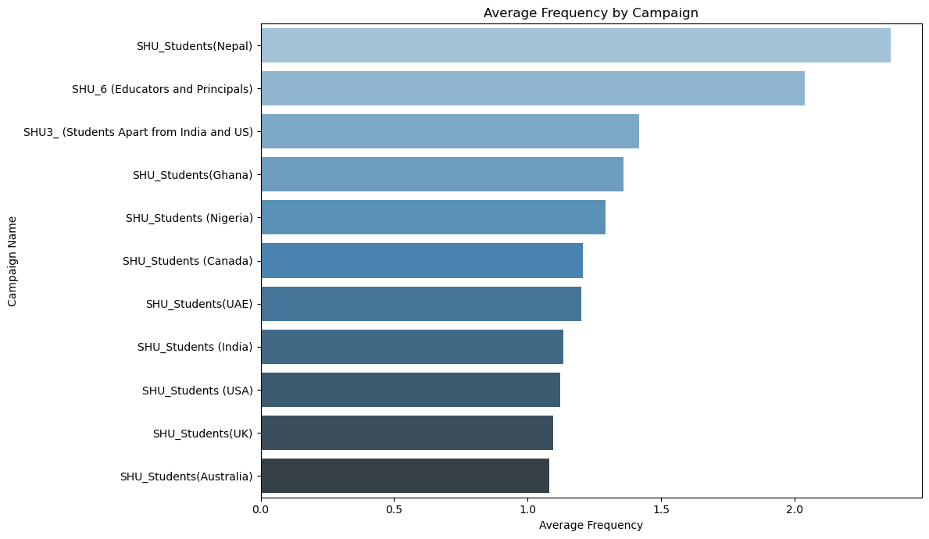

#### **Insight findings:**

|  |  |
| --- | --- |
| Highest Frequency Campaigns | Lowest Frequency Campaigns |
| SHU_Students (Nepal) | SHU_Students (Australia) |
| SHU_6 (Educators and Principals) | SHU_Students (UK) |
| SHU3_ (Students Apart from India and US) | SHU_Students (USA) |
| SHU_Students (Ghana) | SHU_Students (India) |

#### **Interpretation:**

#### The bar chart shows that the campaigns with the highest average frequency were for Nepal, SHU_6 (Educators and Principals), SHU3, and Ghana. This means people in these regions saw the same ad multiple times. On the other hand, campaigns in Australia, UK, USA, and India had the lowest frequency. These ads were not repeated as much for the audience.This helps us understand how often the target audience saw the ads in each region.

## **iv. Average CPR and CPC by Campaign**

#### 

#### **Insight findings:**

|  |  |
| --- | --- |
| Lowest CPR & CPC Campaigns | Highest CPR & CPC Campaigns |
| SHU_Students (Nigeria) | SHU_Students (Australia) |
| SHU_6 (India) | SHU_Students (UK) |
| SHU3_ (Students Apart from India and US) | SHU_Students (UAE) |
| SHU_Students (Nepal) | SHU_Students (Canada) |

#### **Interpretation:**

#### The bar chart shows that Nigeria, SHU_6 (India), SHU3, and Nepal had the lowest average Cost per Result (CPR) and Cost per Click (CPC). This means these campaigns were more cost-effective and gave better results for less money.In contrast, Australia, UK, UAE, and Canada had the highest CPR and CPC. These campaigns were more expensive and less efficient.This helps identify which campaigns gave the best value for money and which ones may need to be reviewed or stopped.

## **v. Amount Spent vs ULC (Scatter Plot)**

#### 

**Interpretation:**

The scatter plot shows the relationship between money spent and Unique Link Clicks (ULC). SHU_Students (USA) performed the best, getting the highest ULC (about 1600) with a low spend of around ₹1000, showing high return on investment. In contrast, SHU_6 (Educators and Principals) spent the most (around ₹2400) but received only around 200 ULC, making it very inefficient. Other campaigns like Australia and UK also spent a lot but got fewer clicks, which shows weak performance.

## **vi. CTR vs Frequency (Scatter Plot)**

#### 

**Interpretation:**

Scatter plot above shows that ads with higher frequency (over 2.0) consistently achieve lower CTRs, indicating audience fatigue. Repeated exposure without engagement suggests declining ad effectiveness. Campaigns like SHU_Students (Australia) and SHU_Students (UK), which had high frequency but weak CTRs, are prime examples. This validates our recommendation to discontinue these campaigns, as they oversaturate audiences without delivering results.

## **vii. CTR & Unique CTR by Campaign**

#### 

#### **Insight findings:**

|  |  |  |  |
| --- | --- | --- | --- |
| Top Performing Campaigns | Click-Through Rate (CTR) | Low Performing Campaigns | Click-Through Rate (CTR) |
| SHU_Students (Nigeria) | ≈ 10% | SHU_Students (UAE) | ≈ 2.5% |
| SHU_Students (USA) | > 8% | SHU_Students (UK) | ≈ 3.5% |
| SHU3_ (Apart from India & US) | ~ 6% | SHU_Students (Australia) | ≈ 4.5% |
| SHU_Students (India) | ~ 6% | SHU_6 (Educators) | ≈ 2.5% |

#### **Interpretation:**

#### The group bar chart shows how well each campaign engaged the audience through Click-Through Rate (CTR) and Unique CTR. The best performers were SHU_Students (Nigeria) with a CTR of around 10%, followed by USA with over 8%, and both SHU3 and India campaigns with around 6%. On the other hand, UAE and SHU_6 (Educators) had the lowest CTRs at around 2.5%, while UK and Australia also performed poorly with CTRs below 5%. This shows that some campaigns were much better at attracting clicks than others.

## **viii. Heatmap (CPR by Age & Geography)**

|  |
| --- |
|  |

#### **Insight findings:**

|  |  |  |
| --- | --- | --- |
| Country | Age Group | CPR (₹) |
| UK | 25–34 | 28.40 |
| Australia | 25–34 | 12.65 |
| UAE | 25–34 | 11.11 |
| USA | 25–34 | 15.75 |

#### **Interpretation:**

#### The heatmap of Cost per Result (CPR) by age and geography shows that the 25–34 age group in countries like the UK, Australia, UAE, and USA has the highest CPR values. This means it costs more to get results from this group. For example, CPR is ₹28.40 in the UK, ₹12.65 in Australia, ₹11.11 in the UAE, and ₹15.75 in the USA. These high costs suggest that targeting this age group in these regions is less cost-effective.

# **Suggested Campaigns to Discontinue**

These ads use a lot of money but don’t get enough useful clicks. So, they should be stopped to save money and focus on better-performing ads.

|  |  |
| --- | --- |
| Campaign Name | Reason for Discontinuation |
| SHU_Students (Australia) | Highest CPR with very low ULC and low CTR. Also has low reach & clicks. |
| SHU_Students (UK) | Extremely low engagement and very high CPR. |
| SHU_Students (UAE) | Poor return with low ULC and high CPR despite moderate spend. Weak CTR confirms it. Also showed ad fatigue (high frequency, low CTR). |

# **Final Recommendation**

SHU_Students (Australia) should be the first campaign to discontinue due to its:

* Highest CPR: The worst among all campaigns, indicating extreme cost-inefficiency for just 3 results as seen from (a. Total Clicks by Campaign)
* Lowest ULC: Lowest ULC & Total Clicks so far, showing negligible engagement and conversion.
* Low CTR: 4.5%, while slightly better than UK and UAE, still indicates weak audience engagement compared to top performers like Nigeria (~10%) or USA (>8%).
* High Spend Relative to Results: The campaign’s expenditure for only 3 results is unsustainable.

The SHU_Students (Australia) ad should be stopped because it is not giving good results. It has the highest cost per result but only got 3 clicks, which means it wastes money. It also has the lowest number of useful clicks and very low engagement. Even though its click rate is slightly better than the UK and UAE, it is still much lower than top campaigns like Nigeria or the USA. Overall, this ad costs a lot but gives very little in return, so it’s better to stop it.

# **Appendix - Additional Visualizations**

*(Supporting charts used during exploration and insight validation)*

## **i .Scatter plot**

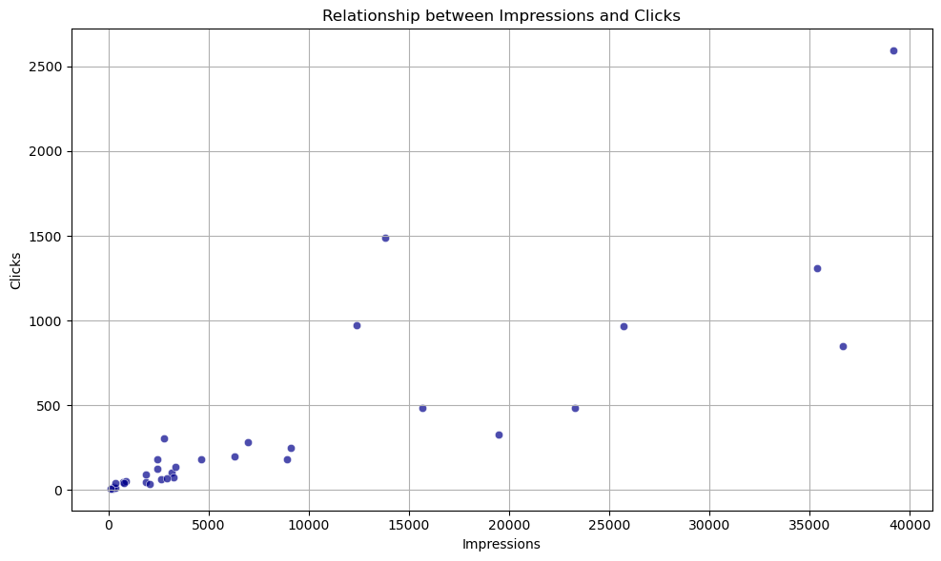The scatter plot showing the relationship between impressions and clicks helps us understand how effective the ads were in grabbing attention. In simple terms, it shows that when more people see an ad (impressions), there is a higher chance that someone will click on it. But this is not always true. Sometimes, an ad may be shown many times but still receive fewer clicks, which means it may not be interesting or engaging enough. On the other hand, some ads get a lot of clicks even with fewer views, showing they are well-targeted and appealing. This plot helps us find which ads are working well and which ones need improvement***.***

## **ii.Bar Chart**

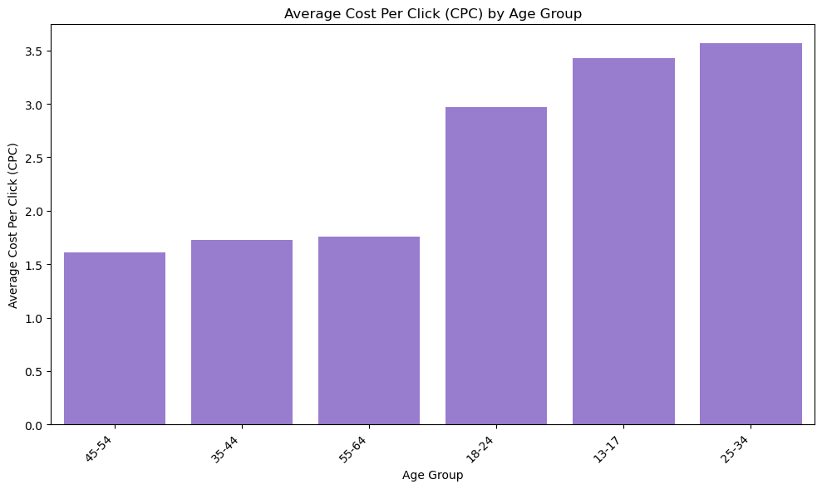

This bar chart shows how much it costs to get one click from each age group. It is clear that some age groups are more expensive than others. For example, people aged 25–34 cost more per click, while younger people like 18–24 are cheaper. This helps us understand which age group gives better value for our ad money.

## **iii. Pie Chart**

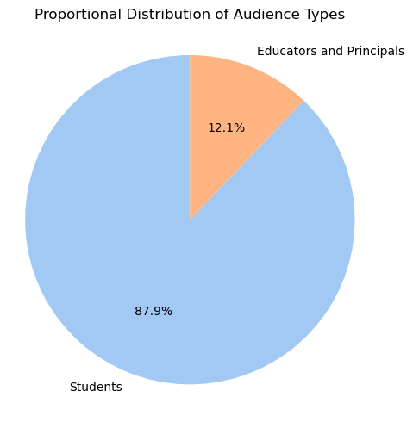

The pie plot shows the total number of people reached by each audience type. It helps us see which group like students, educators, or others saw the ads the most. This makes it easy to compare how widely each ad was shown across different audience categories.

## **iv.Scatter Plot**

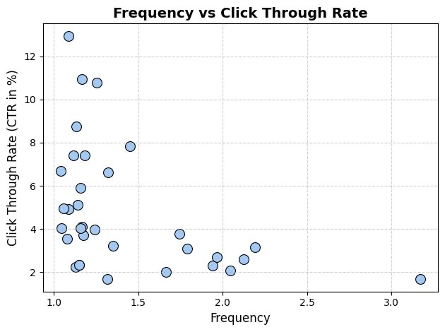

This scatter plot shows the link between how often people saw an ad (frequency) and how often they clicked on it (CTR). If the points go upward, it means showing the ad more helps get more clicks. If not, repeating the ad may not be effective.

**Conclusion**

In today’s fast-moving digital world, making informed decisions is not just an advantage, it’s a necessity. Through this detailed analysis of GlobalShala’s Facebook ad campaigns, we have uncovered valuable insights that demonstrate how data can be used as a powerful guide to improve strategy and save costs. Our findings highlight that some campaigns, while costing more, are bringing in fewer results—proving that higher spending doesn’t always mean better performance. By identifying such underperforming campaigns and recommending discontinuation, we pave the way for smarter budget allocation and improved return on investment.

This project also emphasizes a bigger message that when we trust data and combine it with clear visual storytelling, we unlock the ability to make bold, confident decisions. Every number tells a story, and when analyzed with purpose, these stories lead us to progress. As we move forward, let us remember that impactful decisions are not made with guesses they’re made with insight, intention, and intelligence. Let data light the path to innovation and meaningful change.